This Dairy Lease Agreement is entered into on (date: mm/dd/yyyy)_____________________ between
Owner (Lessor): Name:___________________________________________________
Address: _________________________________________________
Telephone:________________________________________________
Youth (Lessee): Name:____________________________________________________
Address:__________________________________________________
Telephone:________________________________________________
The owner hereby agrees to lease the animal recorded and described below to the Lessee and will provide a copy of the registration certificate if there is one.
Animal Date of Birth:__________________
Breed:______________________________
Registration number and name:___________________
Tattoo and/or other permanent identification_________________
Color markings (may be filled in, if applicable, on the drawing below):
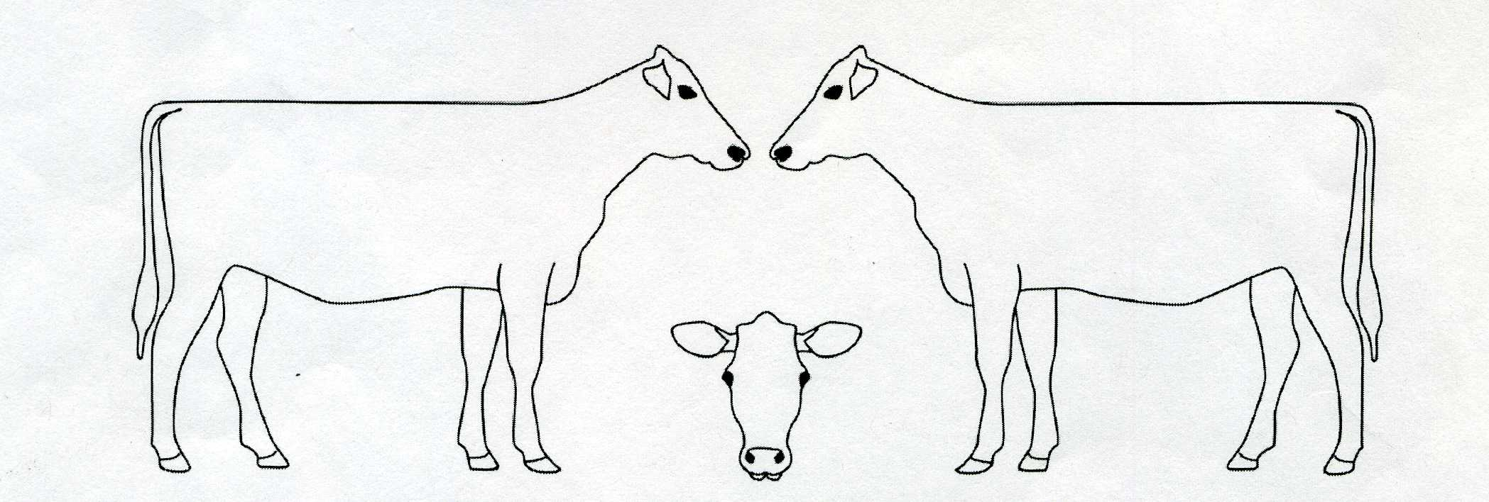
The owner hereby allows the lease of the animal described here for a time period starting on the date above and ending on (Date: mm/dd/yyyy): _________________________upon the following terms and conditions:
- The Lessee will treat the animal in a humane and ethical manner, including feeding, housing, handling, transportation, and veterinary attention that may be required, and will not permit the animal to be mistreated or abused in any way.
- The Lessee may not breed the animal without written permission from the owner.
- The Lessee is responsible for all expenses incurred in exhibiting the animal, such as veterinary, transportation, grooming, feed, and miscellaneous expenditures. Any exceptions must be outlined as follows:

- The Lessee has the right to return the animal to the owner if the youth must change their original intent. The owner has the right to demand the return of the animal if the Lessee is not providing proper care as stipulated in the leasing agreement.
- In case of death of the animal while in possession of the Lessee, it is agreed that:
________________________________________________________________________
________________________________________________________________________
________________________________________________________________________
- The owner is not responsible for injuries to the Lessee, and the Lessee hereby releases liability from the owner for injuries sustained from this animal.
- This agreement must be completed and the animal in possession of the Lessee within the time limits established for ownership by the sponsor of the exhibitor in which the animal(s) will be entered.
- List any additional terms below:
___________________________________________________________________
___________________________________________________________________
___________________________________________________________________
For the Lessee and the Lessor
I have read and understand this lease agreement and agree to abide by its terms and conditions:
_______________________________________________ _____________
Youth (Lessee) Date

_______________________________________________ _____________
Owner (Lessor) Date

For the Parent/Guardian of the Lessee
I have read and understand the contractual agreement entered into by the Lessee and the owner. I agree not to hold the owner liable for any injury or financial liability that the Lessee may incur during this contractual agreement. I will be responsible for any damages or loss because of lack of care by the Lessee:
____________________________________________ ______________
Parent or Legal Guardian Date

